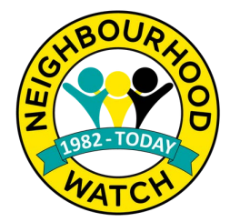
News and Crime prevention advice
Neighbourhood Watch week
More than two million members across the UK have come together to celebrate Neighbourhood Watch Week from 3rd – 9th June.
The charity was founded in 1982 and is the largest voluntary movement focused on crime prevention in England and Wales. The initiative empowers neighbours to work together to build safer, vibrant and inclusive communities, helping to prevent crime and make a positive and sustainable difference.
With more than 400,000 domestic burglaries reported last year, this upsetting crime ranks within the top five most common in the UK, which is why prevention remains a big focus for Neighbourhood Watch.
Over the course of this week, we have released a variety of Crime Prevention advice leaflets via our social media outlets and Community Alert. The leaflets have also been included in this newsletter for you all to share with your groups.

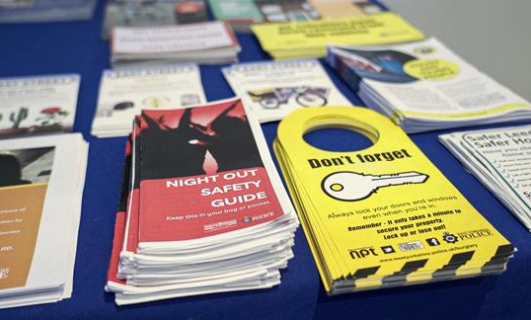

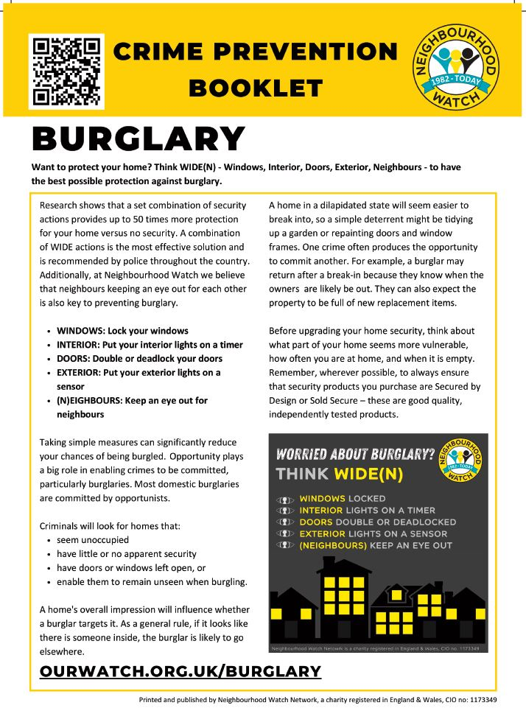
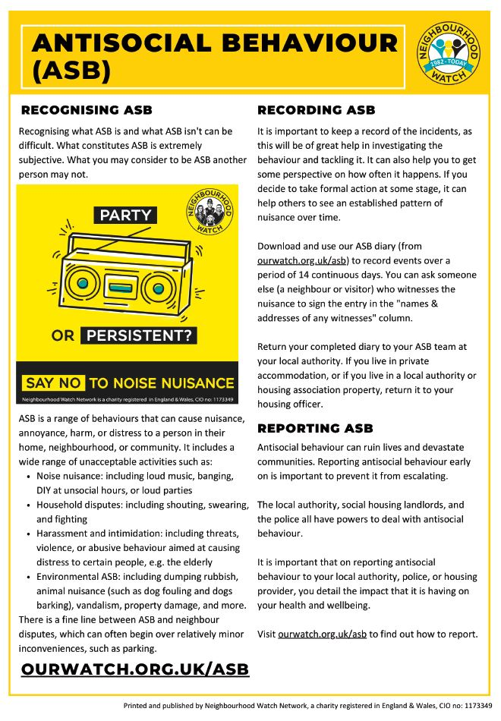
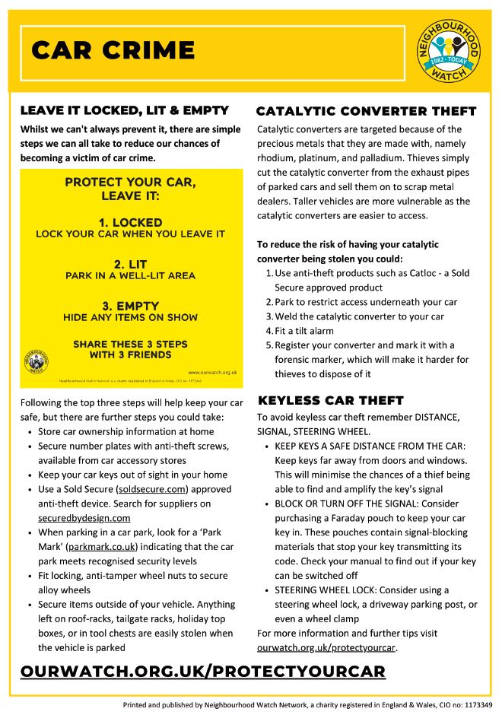
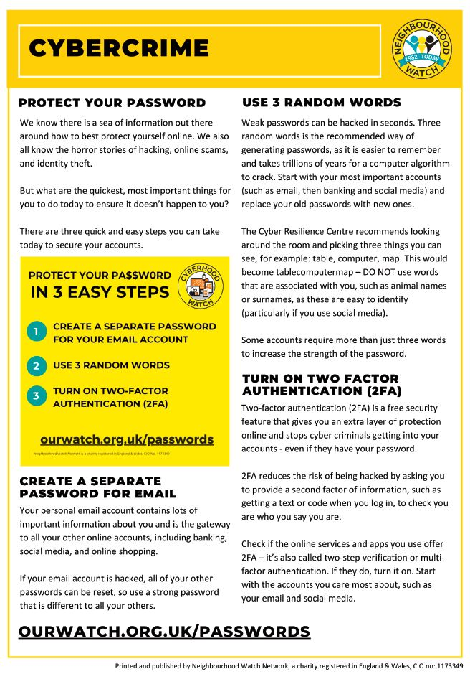
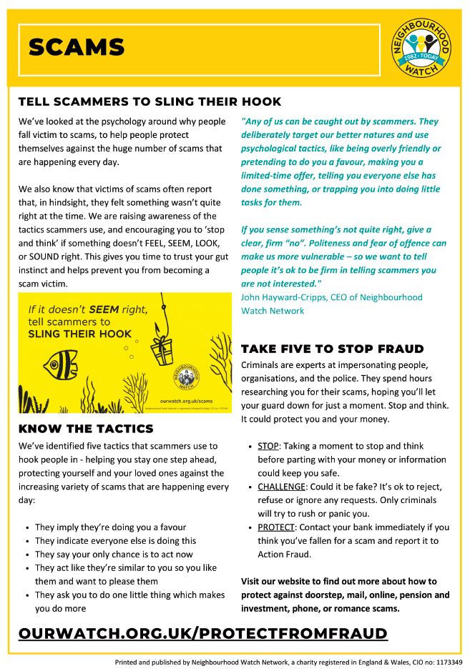
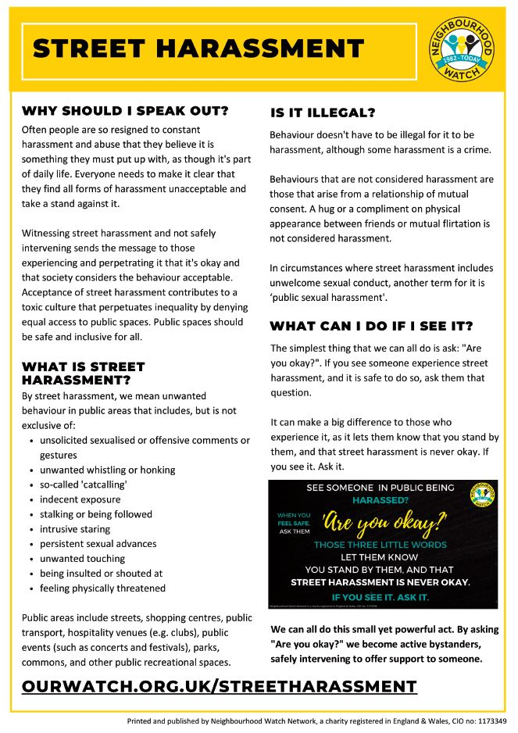

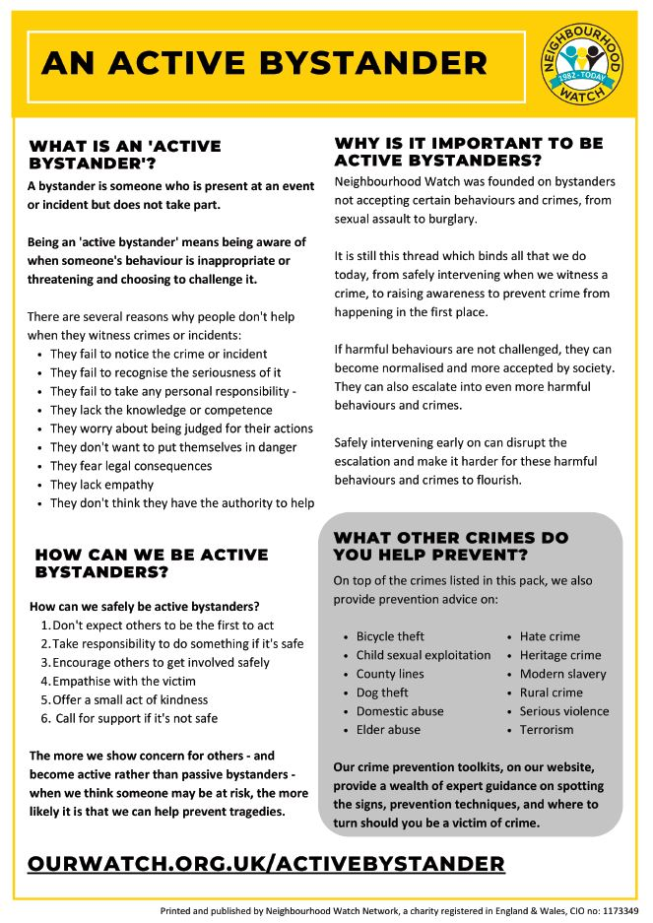

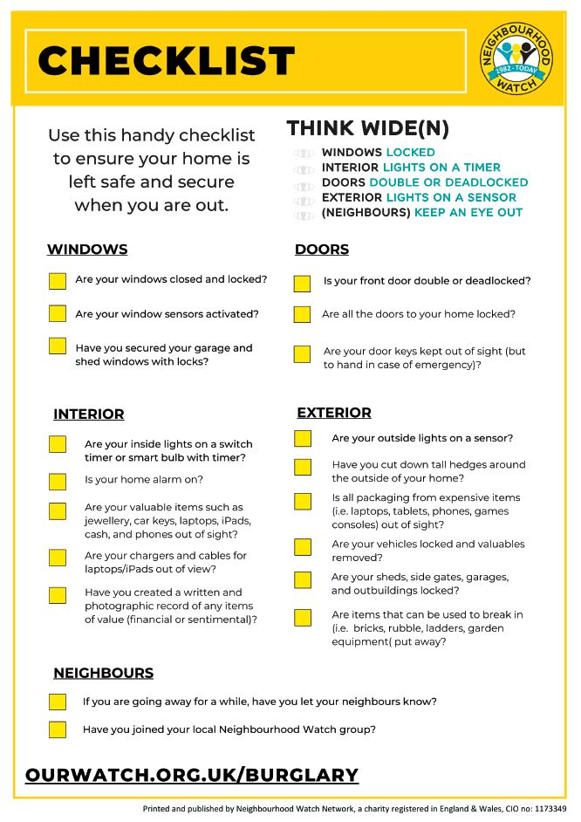

Bogus Callers, Distraction Burglaries & Rogue Traders
There have been a number of reports of bogus callers all across the Leeds District in particular in the Cookridge area.
They will pretend to be on official business from respectable concerns such as the utility companies - gas, electricity and water - or the council. They may claim to be tradesmen or workmen calling to carry out urgent repairs. Bogus callers succeed because they sound believable, so don't be fooled. Follow these simple steps:
- Always keep your front and back door locked
- When someone calls at your door, try to see who it is, always use your chain
- Always ask for proof of identity. Genuine tradesmen will carry an identification card with a photo on it - Ask for photo ID from service or delivery people before letting them in. If you are the least bit worried, call the company to verify.
- Only use trusted and recommended tradesmen; ask friends, relatives or neighbours or contact Age UK or Trading Standards
- Do not allow anyone you don’t know into your home, if they ask you to go outside – don’t
- If the caller wants to sell you something or wants to do any jobs for you say “No thanks” and close the door straight away
- Never tell callers you are on your own
- If you are unsure ask them to call back later and arrange for someone to be with you when they return
- Beware of callers who attempt to distract you by claiming that they have seen something untoward in your rear garden or somewhere which may encourage you to leave your house - they may have an accomplice awaiting this distraction
If in doubt, keep them out!

Ways to contact the Police
As always, if you see anyone acting in a suspicious manner or witness a crime taking place, please contact West Yorkshire Police on 101 or 999 (in an emergency).

It is important that crimes and suspicious incidents are reported via the right channels. This builds a picture of what is going on in our communities and determines how our police resources are used/deployed.

Crime and suspicious incidents – should be reported via the following:
- If you are reporting a crime that is not an emergency, please use 101 or via the online reporting service at www.westyorkshire.police.uk/reportcrime

- For suspicious incidents and to give us information please use 101 or Crimestoppers 0800 555 111
Give information | Crimestoppers (crimestoppers-uk.org)

- If you wish to report anti-social behaviour please use the 101 or report it via www.westyorkshire.police.uk/asbform

Other Information
Join National NHW (OURWATCH)
They are a Home Office supported, registered charity and are the lead in most NHW initiatives.
You can access training and development resources for schemes
You can apply for funding/grants to help your scheme
You can register with both national and West Yorkshire Police NHW.

Join us | Neighbourhood Watch Network (ourwatch.org.uk)

WY Community Alert
WY Community Alert is a communication tool providing our local communities with news and appeals, local crime information and/or prevention advice by email and/or text message. Information is specific to your area. Registering is free, simple, and easy via
Home Page - West Yorkshire Community Alert (wypcommunityalert.co.uk)

